Aquasol Aqua-Grow system comparisons
Aqua-Grow Hobby System
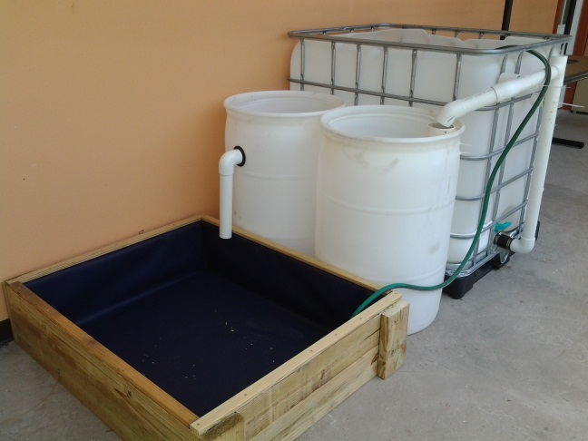
The Aqua-Grow Hobby system is designed for the hobby gardener. Its size and ease of maintenance makes it the perfect initial step into the world of aquaponic gardening. The limited space required for this system makes it ideal for any patio or small yard configuration.
Production expectations (results will vary based on Species, varieties, environment and management)
Fish: 1:10 ratio 27lbs annually 1:5 ratio 54lbs annually
Produce: 1:10 ratio 81lbs produce annually 1:5 ratio 162lbs (Aquaponics produce production may reach as high as 8 x fish production) Total footprint greenhouse10x10
Aqua-Grow Backyard System
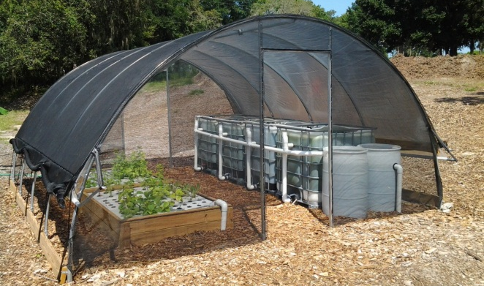
The Aqua-Grow Backyard system is designed for the backyard gardener / farmer that is interested in the beginning steps of food production. This system although four times larger than the Hobby system is designed with ease of maintenance in mind. This system is great to begin personal food production while getting the family involved.
Production expectations (results will vary based on Species, varieties, environment and management)
Fish: 1:10 ratio 110lbs annually 1:5 ratio 220lbs annually
Produce: 1:10 ratio 330lbs produce annually 1:5 ratio 660lbs (Aquaponics produce production may reach as high as 8 x fish production) Total footprint including greenhouse and garden 16x32

Aqua-Grow Homestead System
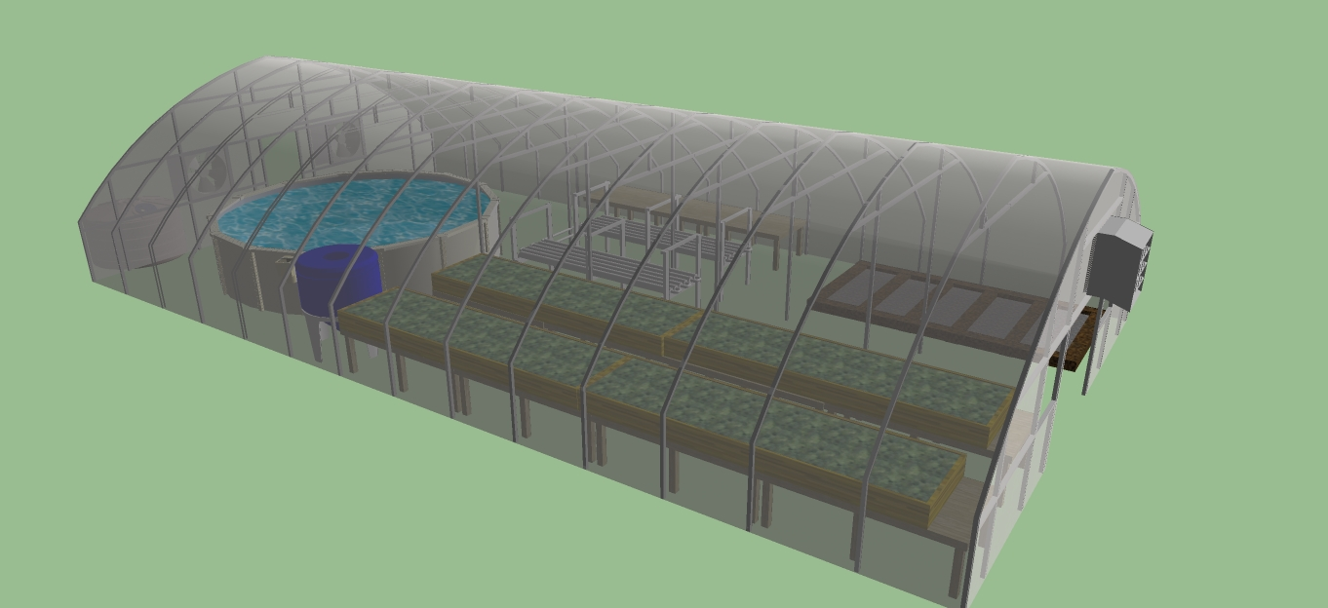
The Aqua-Grow Homestead system is designed for the serious aquaponic farmer looking to produce food sustainably for a family of four. This system is large enough in scale to produce all fish proteins and produce necessary to sustain the average family of four. This system can produce up to 65% of the recommended daily caloric intake. The USDA reports that the average cost to feed a family of four is $1241 per month. These numbers were based on a 2012 report. We have seen food prices increased 19% since 2012 that puts our current total cost to feed a family of four at $1476 per month. The Aqua-Grow Homestead system is one solution to high food cost and a sustainable solution for your families organic food needs.

Production expectations (results will vary based on Species, varieties, environment and management)
Fish: 1:10 ratio 350lbs annually 1:5 ratio 700lbs annually
Produce: 1:10 ratio 1050lbs produce annually 1:5 ratio 2100lbs (Aquaponics produce production may reach as high as 8 x fish production) Total footprint including greenhouse and garden 40x48

